Computing basic network properties
To be discussed in class: a basic understanding of networks: density, reachability, connectivity

import networkx as nx
import matplotlib.pyplot as plt
import numpy as np
G = nx.Graph()
edges = [
("Alice", "Bob"),
("Alice", "Charlie"),
("Bob", "Charlie"),
("Bob", "David"),
("Charlie", "David"),
("David", "Emma"),
("Emma", "Frank"),
("Frank", "Grace"),
("Grace", "Alice"),
("Bob", "Grace")
]
G.add_edges_from(edges)
plt.figure(figsize=(8,6))
pos = nx.spring_layout(G, seed=42)
nx.draw(
G,
pos,
with_labels=True,
node_color="lightgreen",
node_size=1500,
edge_color="black"
)

plt.title("Connected Social Network Graph")
plt.show()

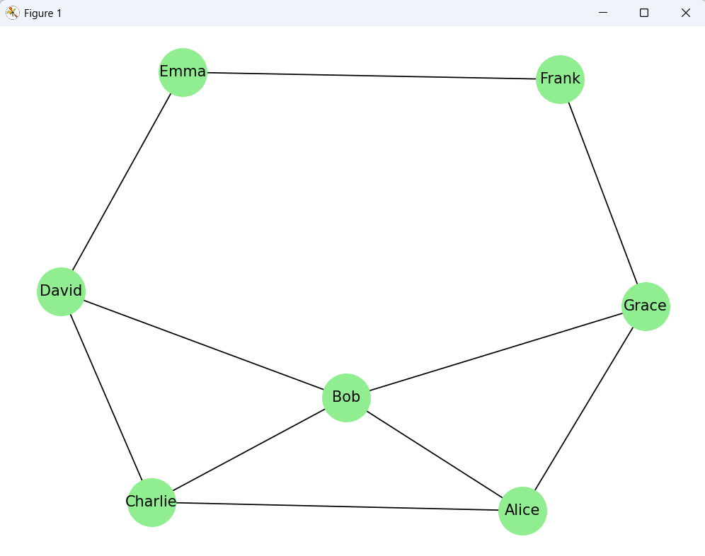

is_connected=nx.is_connected(G)
print(f"Graph is fully recheable(connected):{is_connected}")
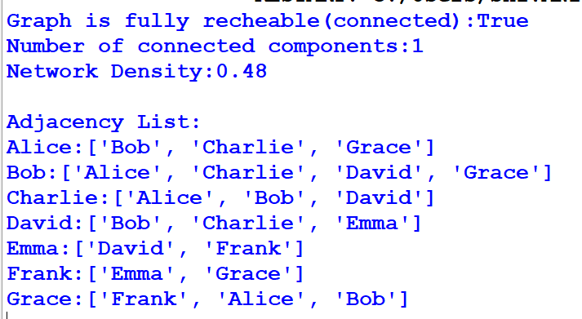

components=nx.number_connected_components(G)
print(f"Number of connected components:{components}")

density=nx.density(G)
print(f"Network Density:{density:.2f}")

print("\nAdjacency List:")
for node in G.adj:
print(f"{node}:{list(G.adj[node])}")

EGO NETWORK
import networkx as nx
import matplotlib.pyplot as plt
G = nx.Graph()
G.add_edges_from([
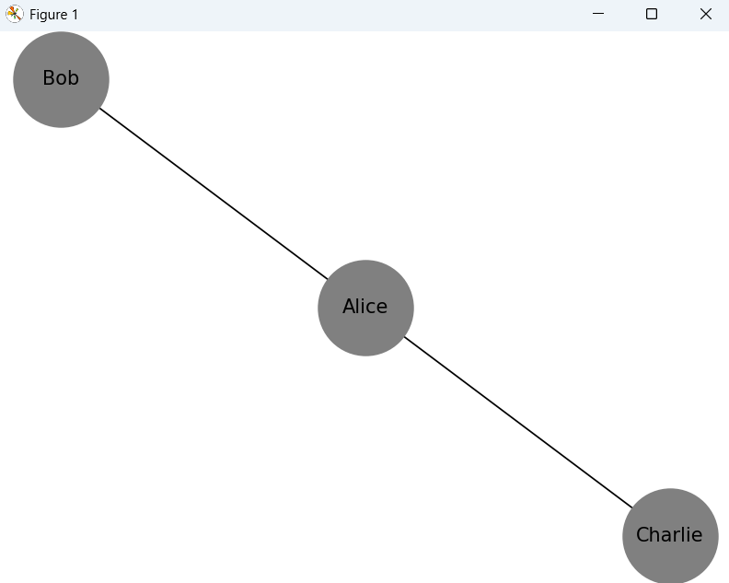
("Alice", "Bob"),
("Alice", "Charlie"),
("David", "Emma")
])
ego = nx.ego_graph(G, "Alice")
nx.draw(
ego,
with_labels=True,
node_color='grey',
node_size=3500
)
plt.title("Ego Network of Alice")
plt.show()

Case Study: Social Media Friendship Network

import networkx as nx
import matplotlib.pyplot as plt

# Create Friendship Network
G = nx.Graph()

friendships = [
("Alice", "Bob"),
("Alice", "Charlie"),
("Bob", "Charlie"),
("Bob", "David"),
("Charlie", "David"),
("David", "Emma"),
("Emma", "Frank"),
("Frank", "Grace"),
("Grace", "Alice"),
("Bob", "Grace")
]

G.add_edges_from(friendships)

# Draw Graph
plt.figure(figsize=(8,6))
nx.draw(
G,
with_labels=True,
node_color="lightgreen",
node_size=1500,
edge_color="black"
)
plt.show()
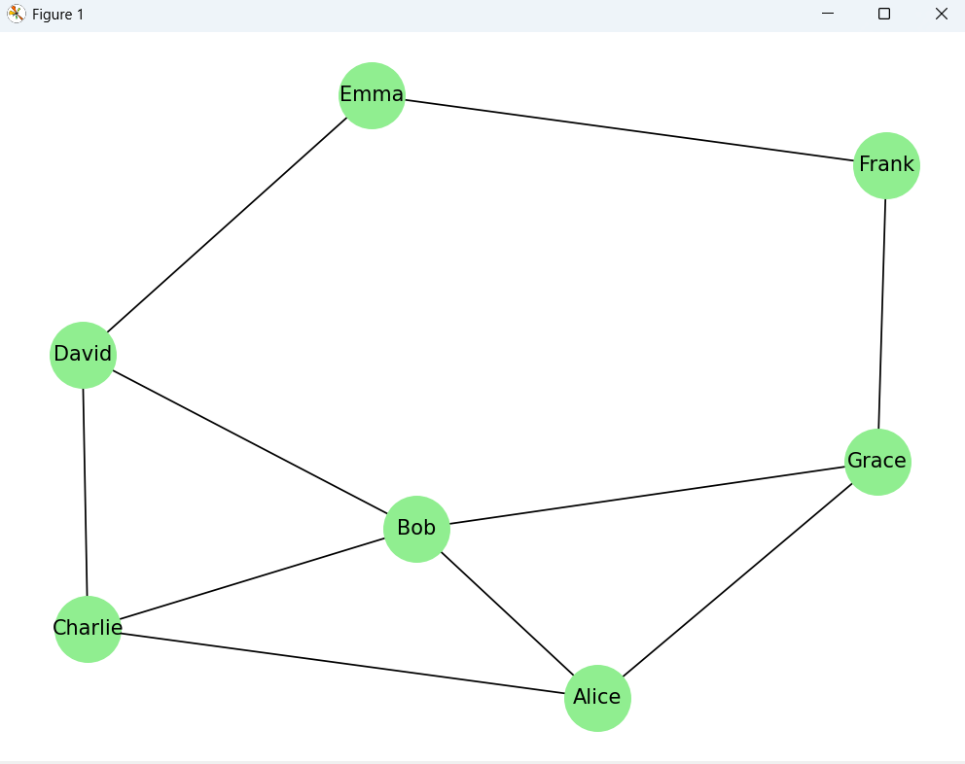
# Number of Edges
print("Number of Edges:", G.number_of_edges())

# Number of Nodes
print("Number of Nodes:", G.number_of_nodes())
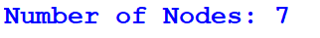

# Degree of Each Node
print("\nDegree of Nodes:")
for node in G.nodes():
print(node, ":", G.degree(node))
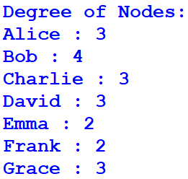

# Node with Lowest Degree
lowest_node = min(G.degree(), key=lambda x: x[1])
print("\nNode with Lowest Degree:")
print(lowest_node[0], "Degree =", lowest_node[1])
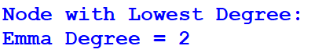

# Adjacency List
print("\nAdjacency List:")
for node in G.adj:
print(node, ":", list(G.adj[node]))
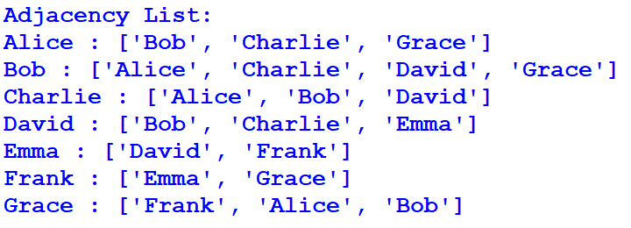
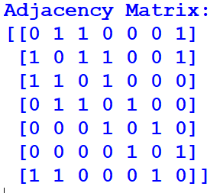
# Adjacency Matrix
print("\nAdjacency Matrix:")
matrix = nx.to_numpy_array(G, dtype=int)
print(matrix)

